Advance Computer network PCS223
Assignment-1
Suryansh Sharma 8025320099

Google ping and captured data packets:
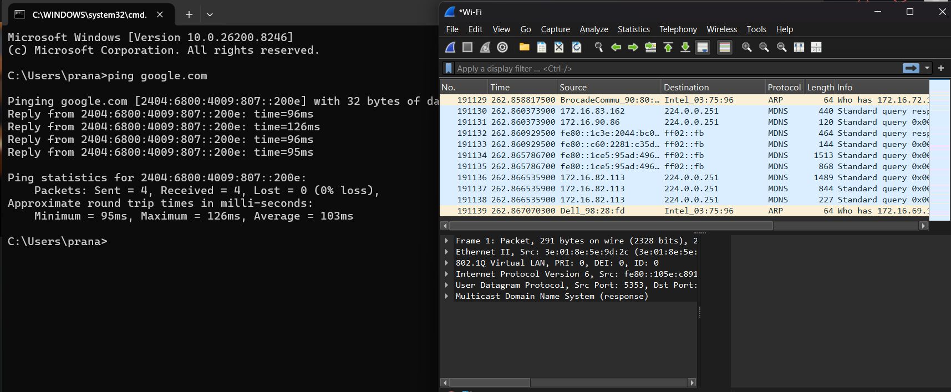

IP filter
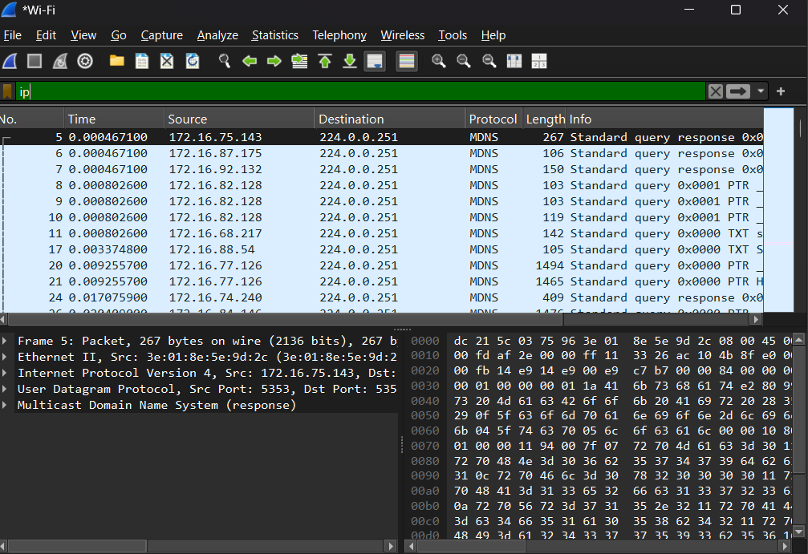

Tcp filter
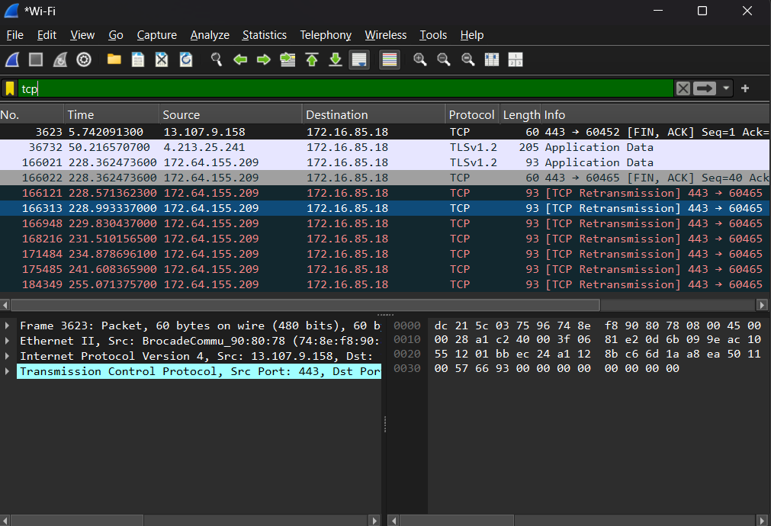
UDP filter
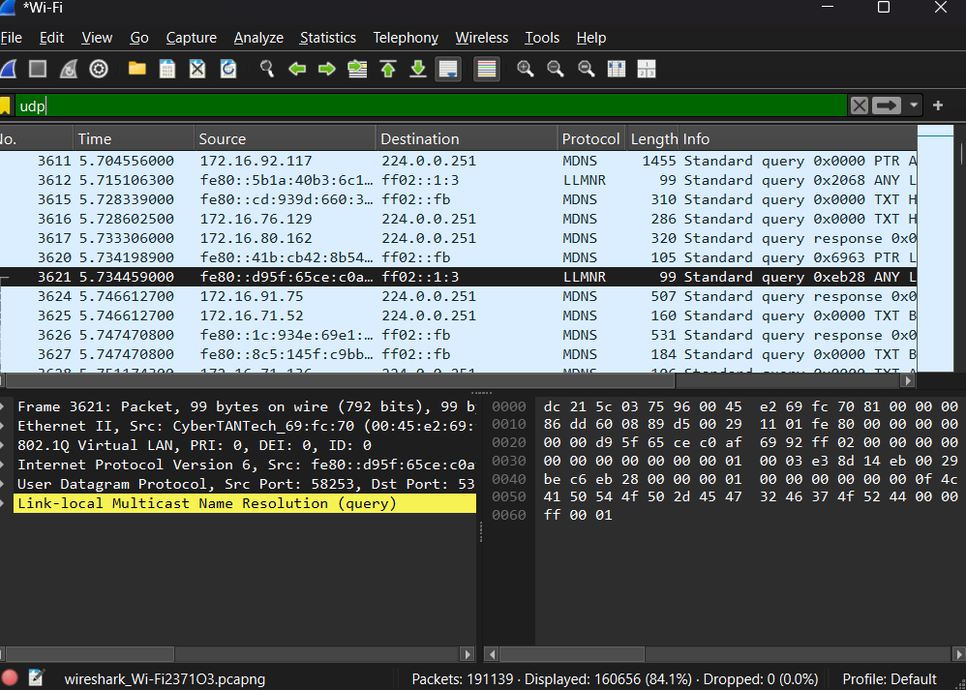
Icmp filter
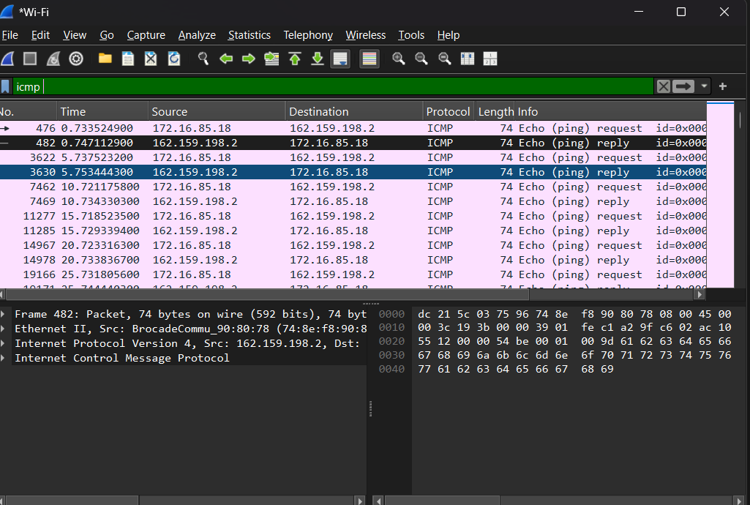
Packet Analysis
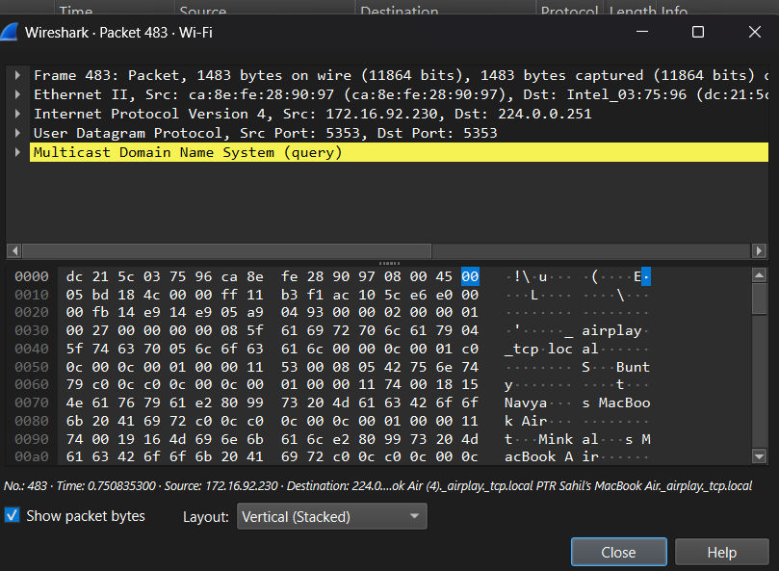
Observation :
- Interface used: Wi-Fi
- Protocols observed: IP, UDP, DNS (Multicast DNS)
- Source IP address: 172.16.92.230
- Destination IP address: 224.0.0.251
- Packet length: 1483 bytes

